sudo fdisk /dev/sdb
In fdisk menu:
n (new partition)
p (primary partition)
1 (partition number - accept default)
Enter (accept default first sector)
Enter (accept default last sector)
w (write changes)

sudo fdisk /dev/sdc
In fdisk menu:
n (new partition)
p (primary partition)
1 (partition number - accept default)
Enter (accept default first sector)
Enter (accept default last sector)
w (write changes)

sudo mkfs.ext4 /dev/sdb1
sudo mkfs.ext4 /dev/sdc1

sudo reboot

lsblk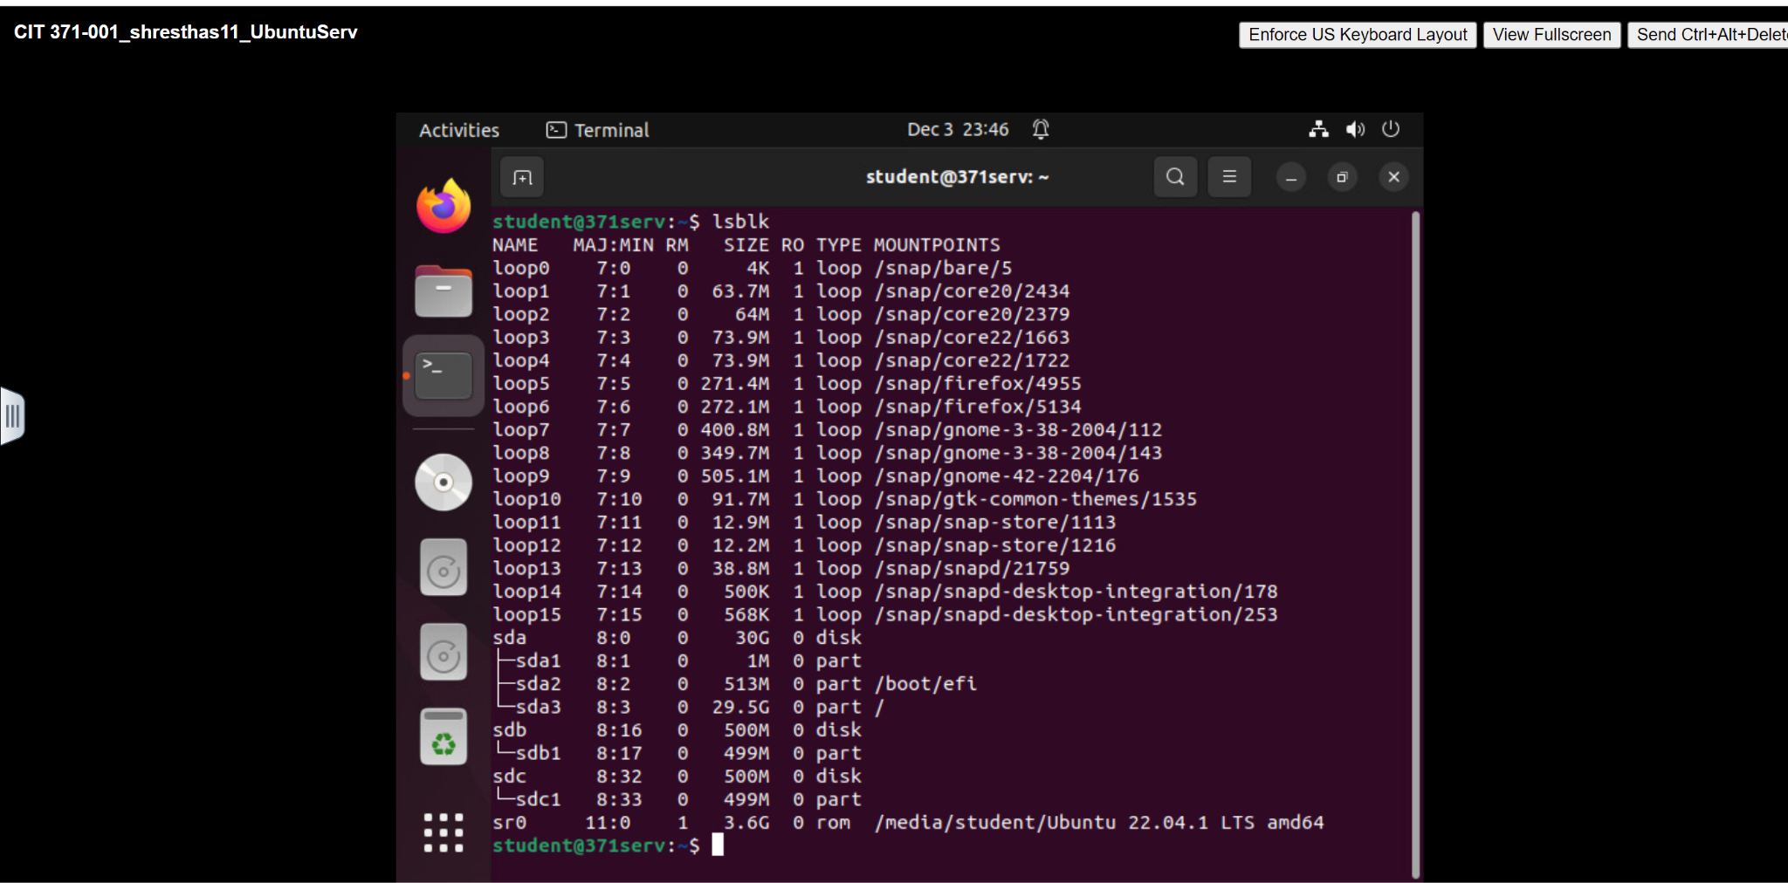

sudo mdadm --create /dev/md0 --level=0 --raid-devices=2 /dev/sdb1 /dev/sdc1
cat /proc/mdstat
sudo mkfs.ext4 /dev/md0
sudo mkdir /mnt/md0
sudo mount /dev/md0 /mnt/md0
sudo mdadm --detail --scan | sudo tee -a /etc/mdadm/mdadm.conf
sudo update-initramfs -u
df -h /mnt/md0

